MAWLANA BHASHANI SCIENCE AND TECHNOLOGY UNIVERSITY
SANTOSH, TANGAIL-1902



DEPARTMENT OF INFORMATION AND COMMUNICATION TECHNOLOGY
Lab Report

Lab Report No : 01
Lab Report on : Image Reading, Display, Grayscale Conversion, and Normalization using
MATLAB
Course Title : Digital Image Processing Lab
Course Code : ICT-4104
Submitted By | Submitted To
Name: Kuldip Saha Mugdha  ID: IT-22018  4th Year, 1st Semester  Session: 2021-2022  Dept. of ICT, MBSTU | Dr. Mst. Nargis Akter  Professor  DEPARTMENT OF INFORMATION AND COMMUNICATION TECHNOLOGY  MAWLANA BHASHANI SCIENCE AND TECHNOLOGY UNIVERSITY

Date of Performance: 28/04/26 Date of Submission: 05/05/26
Introduction:
Digital Image Processing (DIP) involves analyzing and manipulating images using computer algorithms. Images consist of pixels that store color or intensity information. In this experiment, a color image is converted to grayscale and its pixel values are normalized using MATLAB, which are basic and essential steps in image processing.

Objective:
- To read a color image in MATLAB
- To display the image
- To convert the color image into grayscale
- To normalize pixel values for further processing
Software Used:
- MATLAB R2018b

Theory:
Digital images are composed of pixels, each representing intensity values. In color images, each pixel consists of three channels: Red, Green, and Blue (RGB).
Grayscale conversion reduces the image from three channels to one by combining RGB values using weighted averages.
Normalization is the process of scaling pixel values (usually from 0–255) into a range of 0–1. This is useful for many image processing and machine learning tasks.

MATLAB Code:

clc;
clear;
close all;
% Read color image
img_color = imread(‘Kuldip.jpg');
% Display color image
figure, imshow(img_color), title('Color Image');
% Convert to grayscale
img_gray = rgb2gray(img_color);
% Display grayscale image
figure, imshow(img_gray), title('Grayscale Image');
% Read grayscale image (optional)
gray_img2 = imread(‘Kuldip.jpg'); % replace with grayscale file if needed
% Normalize pixel values
img_norm = double(img_gray) / 255;
% Display normalized image
figure, imshow(img_norm), title('Normalized Image');

Output:
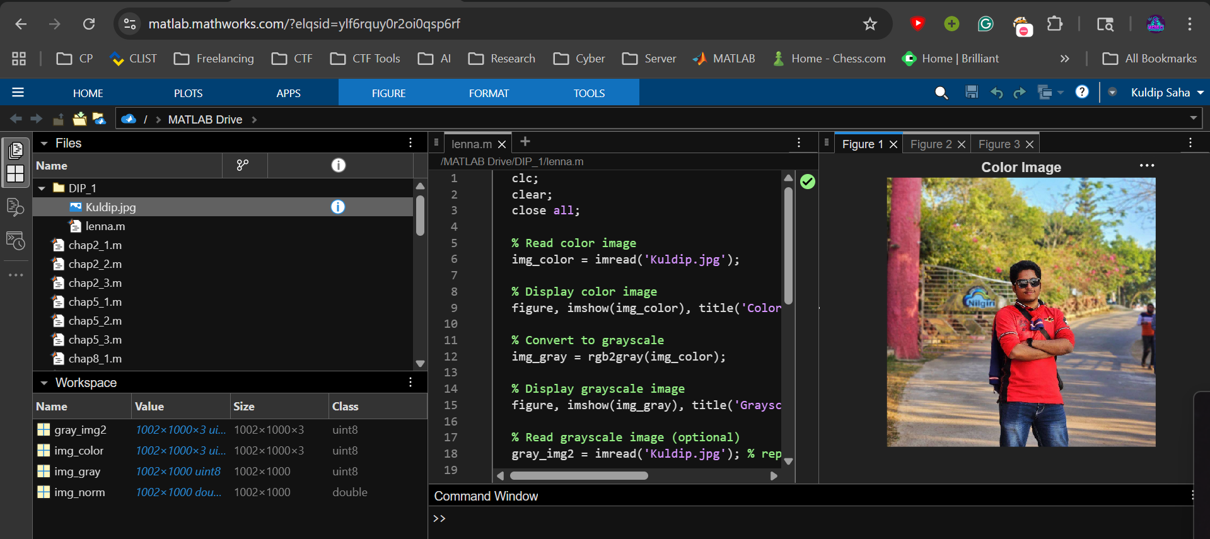
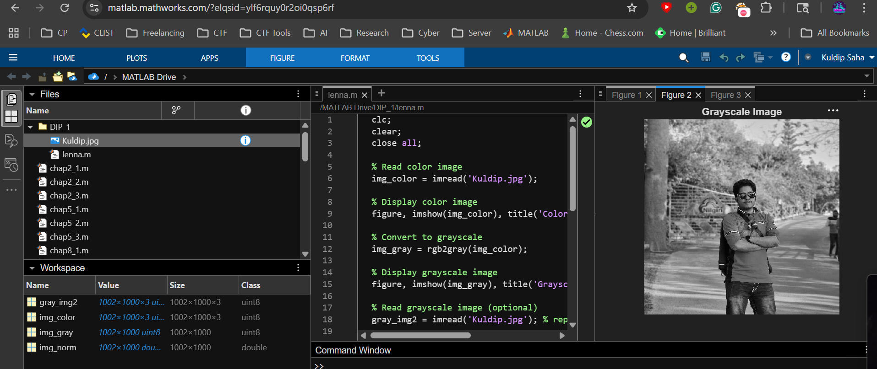
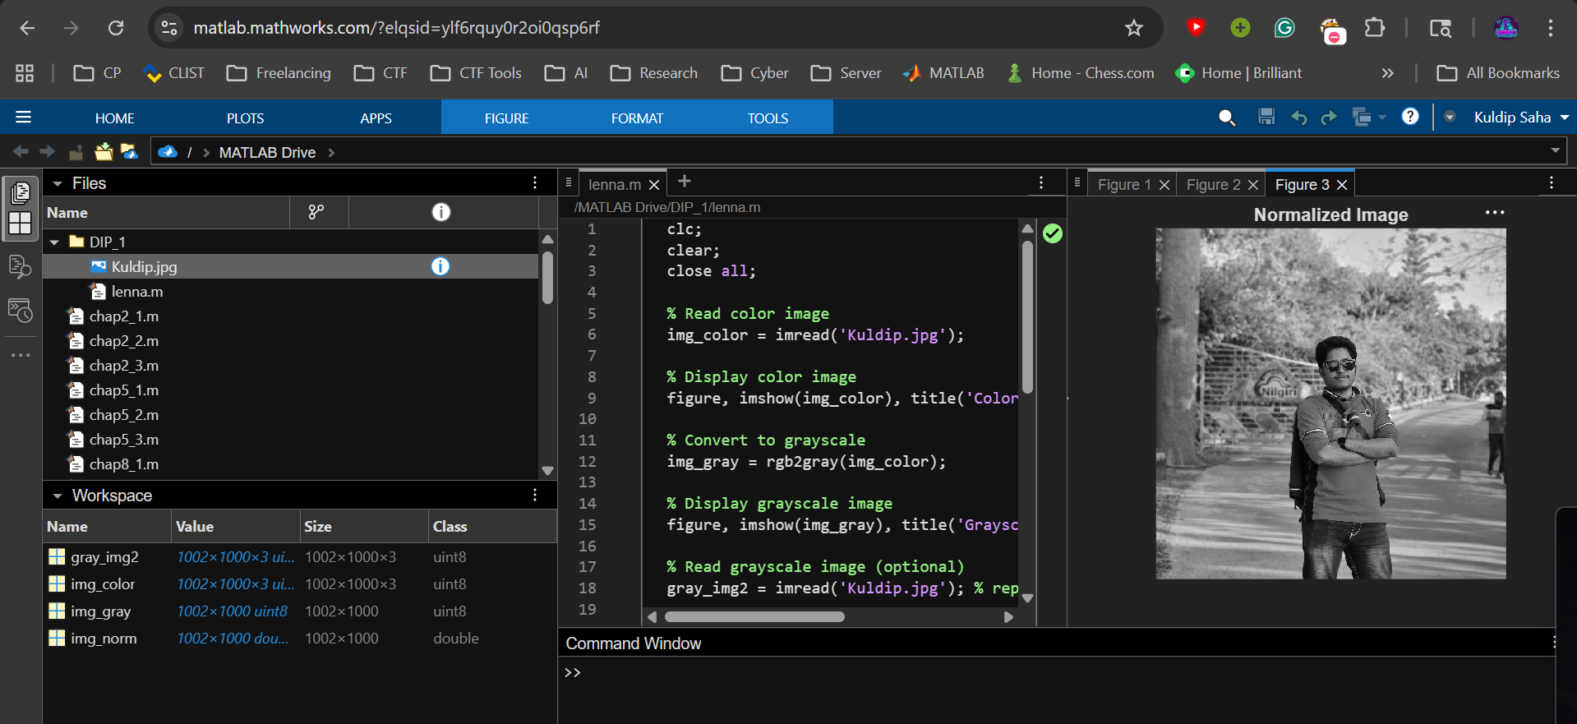

Procedure:
- Start MATLAB and open a new script file.
- Clear previous data using clc, clear, and close all.
- Load a color image using imread().
- Display the image using imshow().
- Convert the image into grayscale using rgb2gray().
- Display the grayscale image.
- Normalize pixel values by dividing by 255 after converting to double.
- Display the normalized image.

Result:
- The original color image was successfully displayed.
- The grayscale image showed intensity variations without color.
- The normalized image displayed pixel values scaled between 0 and 1.

Discussion:
- Grayscale conversion reduces computational complexity.
- Normalization is essential for algorithms that require uniform data ranges.
- The double() function is necessary before normalization to avoid integer division.

Conclusion:
This experiment demonstrates basic image processing techniques in MATLAB, including reading, displaying, converting, and normalizing images. These steps form the foundation for advanced image processing tasks.

